How to Set Up SFTP in Windows server 2016

- Download OpenSSH from this link and extract the zip file.
- Rename the folder name from OpenSSH-Win64 to OpenSSH
- Copy or move the folder into “C:\Program Files” directory
- Run Windows PowerShell as administrator.
- Now Run following commands:
- cd "C:\Program Files\OpenSSH"

- powershell.exe -ExecutionPolicy Bypass -File install-sshd.ps1

- New-NetFirewallRule -Name sshd -DisplayName 'OpenSSH Server' -Enable True -Direction Inbound -Protocol TCP -Action Allow -LocalPort 22

- Go to “C:\Program Files\OpenSSH” directory and search for a file named “sshd_config_default” open the file with administrator access.
- Search for “ChrootDirectory none” and replace the none with your ftp server root directory and save the file.
- Go to “C:\ProgramData\ssh” directory and search for a file named “sshd_config” open the file with administrator access.
- Search for “ChrootDirectory none” and replace the none with your ftp server root Path and save the file.

- Press Win+R and type “services.msc” then press enter.
- Search for a service named “OpenSSH Server” , set the service as automatic and start the service.
- Now Open file fileZilla client and go to File > Site Manager;
- Click on New Site and give an appropriate name.
- Now Give the following configuration:
- Protocol => SFTP- SSH File Transfer Protocol
- Host => *
- Port => 22
- User=> Your FTP user
- Password => Your FTP user password.

- Now click on OK.

Your hard work is done. Now just connect the server And you're good to go.

Useful ScreenShoots :
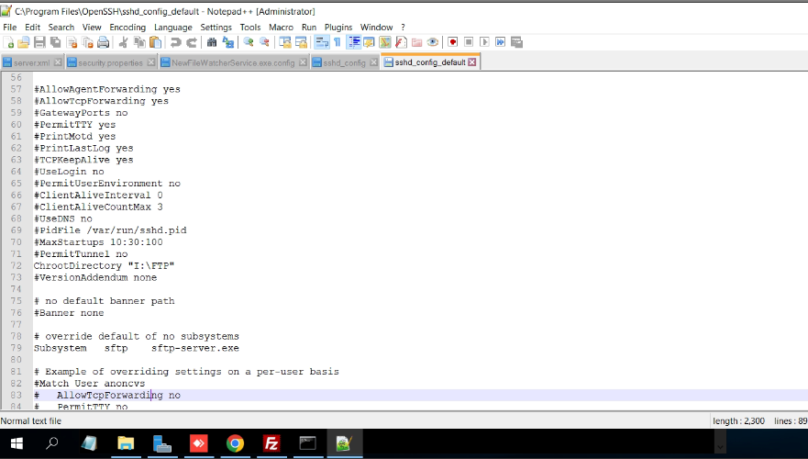

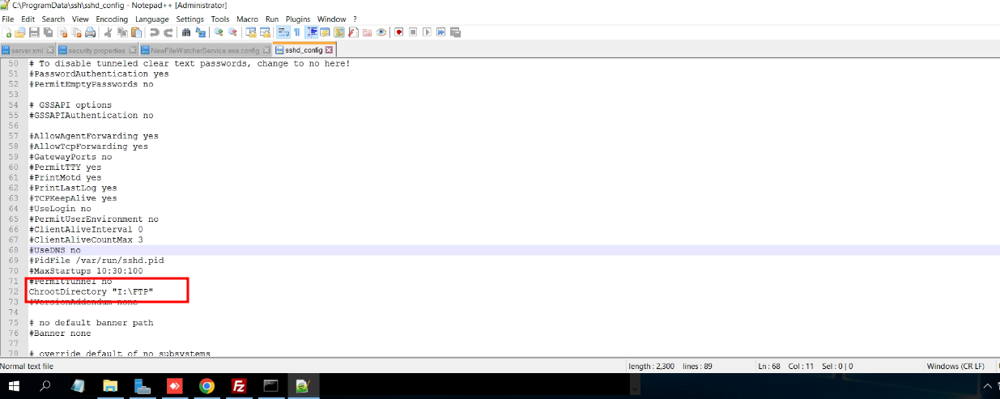

PS: If faced any error then please check the steps again.

